Name: Shazia Naz

Roll No. 00106485

**Title: “Marketplace Technical Foundation-[Design-o-Pedia]”**

­­­­­This document describe the user journey flow for an e-commerce marketplace, focusing on key steps and their technical implementation. It is tailored for building a robust and user-friendly platform.

1. System Architecture Overview

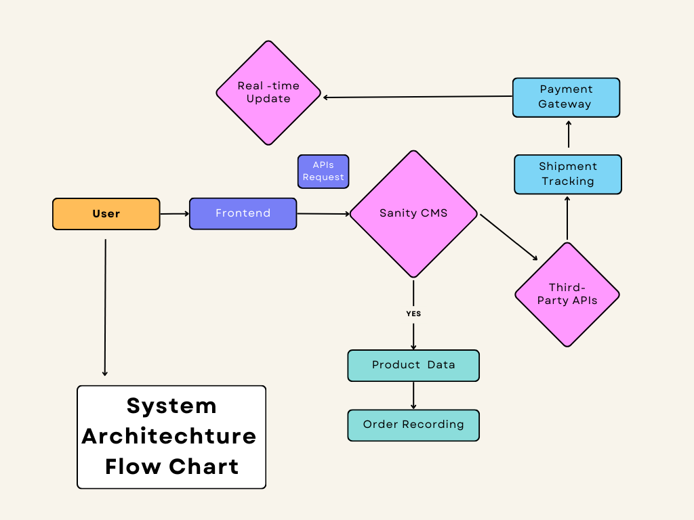

* **Frontend (Next.js):**
  + Tailwinds: for responsive, user-friendly interface.
  + Handles product browsing, cart management, and checkout processes.
  + ShadcnUi: for Customization
* **Backend Sanity CMS:**
  + Manages product data, customer details, and order records.
  + Acts as the database for the e-commerce store.
* **Third-Party APIs:**
  + Stripe/ShipEngine: Manages payment processing and shipment tracking.

1. Key Workflows

### 1. User Registration:

1. User fills the signup form on the frontend.
2. Frontend sends user data to Sanity CMS API.
3. User details are stored in the CMS.
4. Confirmation is sent back to the user.

### 2. Product Browsing:

1. User visits the product listing page.
2. Frontend requests product data from Sanity CMS.
3. Products are dynamically displayed to the user.

### 3. Order Placement:

1. User adds products to the cart.
2. User proceeds to checkout and enters payment details.
3. Order details are sent to Sanity CMS for recording.
4. Payment is processed via a payment gateway.
5. Order confirmation is displayed to the user and saved in Sanity.

### 4. Shipment Tracking:

1. Shipment tracking data is requested from a third-party API.
2. Updates are displayed to the user in real-time on the frontend.

### Product Schema:

### export default {

### name: 'product',

### type: 'document',

### fields: [

### { name: 'name', type: 'string', title: 'Product Name' },

### { name: 'price', type: 'number', title: 'Price' },

### { name: 'stock', type: 'number', title: 'Stock Level' },

### { name: 'description', type: 'text', title: 'Description' },

### { name: 'image', type: 'image', title: 'Product Image' }

### ]

### };

### APIs ENDPOINT:

|  |  |  |  |
| --- | --- | --- | --- |
| **Endpoint** | **Method** | **Purpose** | **Response** |
| /product | GET | Fetch all products | {"id":1,"name":product1}  LIKE product ID,name,price |
|  |  |  |  |
| /order | POST | Fetch all products | {"orderId":12345,"status":"shipped"}  like orderId,total cost, status |
|  |  |  |  |
| /shipments | GET | Fetch all shipments | {“orderID”:12345,”status “:”shipped”  Like shipment ID,order ID,status |
|  |  |  |  |

1. User Interaction (Frontend)

|

v

2. Product Browsing

|

-> Request Product Data

|

v

[Sanity CMS]

| |

| v

| Fetch Product Data

|

v

3. Add to Cart

|

v

4. Checkout

|

-> Send Order Details

|

v

[Sanity CMS]

| |

| v

| Record Order Details

|

v

5. Payment Processing

|

-> Communicate with Payment Gateway

|

v

[Third-Party APIs]

|

v

6. Order Confirmation

|

v

7. Shipment Tracking

|

-> Fetch Shipment Status

|

v

[Third-Party APIs]

|

v

8. User Views Updates